- Call to Order – Amy Bocks
  - Meeting was conducted in person at the Arizona Criminal Justice Commission and virtually via Zoom and called to order at 10:06 am. by Amy Bocks.
Attendees
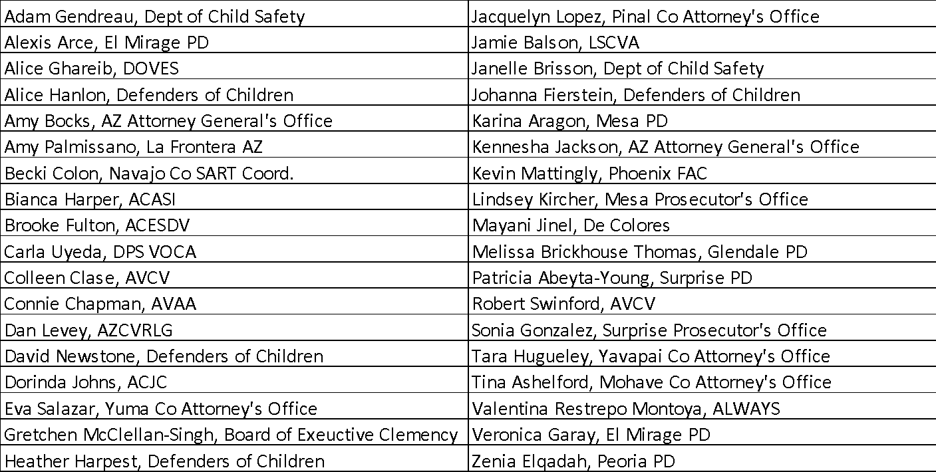
- Welcome and Introductions
  - Introductions by in person and virtual attendees.

- Approval of July 2022 Meeting Minutes
  - No comments or corrections.
  - Motion to approve by Adam Gendreau, 2nd by Tara Hugueley.
  - Minutes were approved via hand raise in person and reaction function virtually by all voting members present. No opposition.

- Johanna Fierstein, Defenders of Children
  - Introductions and overview of agency.
    - Provide free legal and clinical therapy services to victims of crime with a focus on survivors of child abuse and domestic/family/sexual violence.
    - Collaborate with community victim services partners.
    - Website: https://defendersofchildren.org/ Email: staff@defendersofchildren.org Based in Phoenix but take cases from all areas of the state.
  - Legal Services Department – Attorney David Newstone
    - Provide support in family Law, divorce, and custody matters. There is limited capacity and they have to prioritize cases. Even if they can’t represent someone they will offer referrals, information, and resources to everyone. They focus on children or parents/guardians of children due to the limited capacity.
    - Services provided in other areas include things such as: landlord tenant, consumer law, and public benefits as long as there is a nexus between what they need and their status as a victim of crime. In regard to criminal set asides they will provide information and resources but not represent clients for that purpose.
    - In criminal court cases they may act as legal counsel in some circumstances for children only.
    - They serve as the de Facto law firm for nonprofit agencies and shelters who don’t have income eligibility requirements. They are available to non-attorney advocates to assist in answering questions and providing information.
    - They will assist limited English proficiency clients – Spanish and other languages.
  - Clinical Mental Health Department
    - Provide holistic services for victims of crime to help ground and stabilize survivors to build resilience and prepare to face their abusers. Services are focused on family violence, trafficking, sexual violence, and child abuse survivors. Services include: trauma therapy, support groups, EMDR, and multiple modalities.
    - Provide services to children under court ordered family time with supervision.

- Lifetime Injunctions Discussion, A.R.S. 13-719 (SB1653)
  - These became effective 09/24/2022 – are agencies aware and how are they informing victims.
    - Jamie Balson – Katie’s Law – 2022 made substantial changes to the law – they are doing a 2 hour presentation on this on Friday in great detail. The link is on the lscva.org website. LSCVA has proactively reached out to clients to find out if they are interested and the overwhelming response is that they are interested in obtaining the injunction. They also posted information on their website for victims. LSCVA will actively track cases since they are not done through the AZ Point system that is likely where there will be the most problems. LSCVA will take cases if you have referrals, they have staff ready to go on these cases.
    - There has to be a criminal case felony conviction and specific crimes are listed. Victims need to go back to court where conviction took place and request the lifetime injunction there. The courts have draft forms that are not finalized yet. There is no requirement that the victim come to court to face the defendant unlike standard protective orders.
    - Colleen Clase - AVCV can also assist with these cases even if they haven’t helped the victim with the criminal case in the past.
    - David Newstone – Defenders of Children may be able to assist if needed.
    - Valentina Restrepo Montoya – ALWAYS can assist - info@alwaysaz.org.
    - Dan Levey – AZCVRLG may be able to assist and if not they will refer to the appropriate agency.
    - Amy Palimssano asked if offenders have the right to contest the order. Jamie Balson shared that these are not discretionary – if it meets the elements of statute it SHALL issue.
  - The courts and Administrative Office of the Court have been meeting to determine the process.
  - Jamie Balson indicates there are probably going to be constitutional challenges on these and some victims may be best waiting to see if there are changes.

- By-laws and Operational Guidelines
  - There will not be a vote today but there will be a vote in November on the changes to By-Laws and Operational Guidelines.
  - Minor changes were distributed to membership via email and are on the website – please review and bring comments to the November meeting.

- Legislative Priorities
  - Kennesha Jackson, AZ Attorney General’s Office:
    - No new updates
    - VR Brief reviews new legislation this year. Victims' Rights Brief 2022 Legislative Update https://www.azag.gov/sites/default/files/docs/criminal/victim-services/vrb/VRB-September-2022.pdf
  - Dan Levey, AZ VRCLVG
    - They are looking at ARS §31-230 restitution from prisoner spendable accounts. The rate is currently set at 20%-50% unless there is a court order to take more than 20% that is the amount taken. In cases where the offender received a lengthy prison term cases they have gotten orders up to 50% however some courts are stating it’s not their decision, that it’s up to the executive branch and the ADCRR director. They will be seeking clarity on this issue, there is no pending bill at this time. Jamie Balson indicates that LSCVA will support this bill.
  - Brooke Fulton, ACESDV: victims do not have to pay for sexual assault exam fees; HB2709 - redact victim info from body cam footage, including address; and HB2604 longer term orders of protection. Several initiatives failed last session and they will have new bills next session.

- Updates from ACESDV:
  - ACESDV - same as above

- State Agency Coordinating Team (SACT) – Funders Reports
  - VRP – Kennesha Jackson, Arizona Attorney General’s Office:
    - FY 2023 Funding Update: Award agreements have been issued and funding will be disbursed upon receipt of signed award agreements. We anticipate that funding will be distributed in two payments throughout the fiscal year. We are also currently in the process of reviewing FY22 annual reports and any modifications that are required will be requested in October.
    - Victim Request/Waiver forms: Updated 2022/2023 R/W Forms (paper and electronic versions) have been distributed to all law enforcement agencies. Law enforcement agencies should use the new updated forms as there have been multiple changes to the information and resource sheet. We also highly recommend law enforcement agencies begin using an electronic version of the R/W form, if you are able to implement the electronic form into your system. The AGO is also working with ADOT to finalize usage of the R/W form in AZTRACS, an electronic forms management software. The form will be available for law enforcement agencies to use in January 2023. Paper shortage and increased paper costs – try to use electronic versions to offset these problems.
    - Victims’ Rights Education: Victims’ Rights presentations will continue to be conducted via webinar through the next fiscal year. Please note that the new Advanced training curriculum and updated Basic will be available starting October 2022. This year’s Advanced training will be: Navigating Victims’ Rights in the Juvenile Justice System. For more information on the schedule, to register, or to request presentation for your office please contact OVSTraining@azag.gov.
- ACJC – Dorinda Johns:
    - The VINE project is moving forward. Expecting to have it completed in the next few months following a one-year extension that was granted.
    - This year is the first time there is an addition of general funding into the Victim Compensation (VC) and Victim Assistance (VA) budget ($2 million) and one-time $10 million in ARPA funds. The VA Application period should be open in January or February and based on the significant change in short term one-time dollars available they might be able to fund one-time purchase items.
    - At the October Crime Victims Committee meeting they will set priorities for the upcoming program period. The public can provide comments about what needs are.
    - VC rules and VA rules are due and they are planning to petition the Governor’s office to open rule planning. There will be a series of public meetings throughout once rule making opens.
- VOCA – Carla Uyeda:
    - Current FFY is ending in 9 days. Grant administrators sent out emails with the end of year deadlines and instructions. The September financial report is due 10/15 but you have to do a year end amendment before you submit the report. Your balance should be $0 after submitting the September financial report. The Q4 program report and Annual narrative are due 10/30.
    - There is no contract process for transition from year 2 to 3. There will be a few things that need to be completed that Carla will send out.
    - After year 3 DPS is considering doing one-year renewal instead of a 3-year process due to the health of the crime victim fund. The fund is very low at this time. There may be a significant cut based on your year 3 award and this could be as high as a 50-60% cut in the renewal year. Neither DPS or OVC have any more information at this time. OVC has information on their website with the fund balance that is updated monthly. You can find OVC Crime Victim Fund balance and deposit graphs at https://ovc.ojp.gov/about/crime-victims-fund.
    - DPS will be sending instructions in the next few weeks and the official announcement should be in February 2023.
    - Dan Levey inquired if new agencies can apply for the one year renewal. Carla stated it would likely be only for current recipients.
    - Contact Carla with any questions: cuyeda@azdps.gov
- DES – Not Present
- DHS – Not Present

- Arizona Victim Assistance Academy (AVAA) – Connie Chapman
  - The Basic Academy just finished in Flagstaff and there were 41 attendees.
  - The Advanced Academy will be held in November on Trauma Informed Care and information will go out in the next few weeks.
  - Another Basic Academy will be held in January and dates will be determined soon.
  - Through the Mobile Advocacy Program (MAP) AVAA is touching agencies they haven’t touched before. The Pima County Court Appointed Special Advocate will be trained in October, Social Workers at MAYO Clinic were trained on trauma and trafficking and crisis intervention and Chrysalis has reached out.
  - If you have ideas for training on Advanced topics let Connie know.

- Committee Reports
  - Executive Board Report – Chair Amy Bocks
    - By-Laws and Operational Guidelines – modifications are available for review in preparation for the November meeting vote.
    - Thank you ACJC for the conference room. The Phoenix Family Advocacy Center doesn’t have technology available so we are still looking at other options.
    - Is hybrid format working? Positive responses from attendees that feel the hybrid format is working well.
  - Treasurer’s Report – Karina Aragon
    - ACVS: $4,935.81 – significant decrease due to the Academy and administrative costs. Grant reimbursements are currently pending.
    - AVAA: ($3,961.44) – significant decrease due to the Academy and administrative costs. Grant reimbursements are currently pending.
    - Relocation: $291.56 – Received a $12 check that will be reflected in the next cycle.
    - TOTAL: $1,265.93
  - Vice Chair – Adam Gendreau
    - Membership receipt letters for payments have all been sent, if you don’t have one reach out to Adam ASAP.
      - Adam, Dan Levey and Virginia Rodriguez have met a few times as the Membership Committee and have reached out directly to several agencies. This outreach has helped and there is larger attendance this year.
      - If you have questions about payment or your confirmation – reach out to Adam, Karina or Connie Chapman.
    - If you wish to join any committees, reach out to a member of the Executive Committee.
    - November elections – the Chair and Secretary positions are up for election in November. If you are interested, reach out to a member of the Executive Committee and send us a short statement about yourself for the November meeting.
  - Relocation Committee – Tracey Wilkinson
    - There is now a phone collection flyer for DV awareness month available for agencies to use and information about the types of devices accepted will be added. October is DV Awareness Month so it’s a good time to do an agency drive.
    - A tax receipt is available and will be shared with ACVS members.
    - Contact Tracey if you have any questions and please note, when sending the cell phones for the ACVS Relocation Project, please include the address for ACVS so the funds are received by ACVS. More information can be found here: https://smartphonerecycling.com/?msclkid=b534553c694816ed297837e4290440df
  - Website Committee – Adam Gendreau
    - Many links that are on the ACVS website were out of date and they have been corrected. If you see one that isn’t correct let Adam know.

- New Business/Open Forum
  - Amy Bocks - the AGO has an open position for an agency support team member. The position is open until filled and can be found on the state jobs website. This is a brand new position. If you want specific information, email Amy at. amy.bocks@azag.gov
  - Adam Gendreau - DCS also has a position open that was sent out through listserv. This is a Phoenix liaison position but may have 50% of the workload in the southern region in Tucson. Email Adam if you have any questions: adam.gendreau@azdcs.gov
  - Dan Levey – December 3rd Parents of Murdered Children and AZCVRLG are holding a fundraiser. "Knocking Down Pins For Healing and Justice" Bowling Fundraiser, POMC and Arizona Crime Victim Rights Law Group, Dec 3rd, 10am-noon. Bowlero at 17210 N. 59th Ave. More Info to follow. Sponsorships, Silent Auction, Team Registrations, DJ, 2 pieces of pizza, 2 hours of bowling, shoes, unlimited soda! They invite agencies LE, AG's, County Atty's, city prosecutors,,individuals, families, victims/survivors,etc. POMC provides ongoing emotional support to those who have died by violence. Arizona Crime Victim Rights Law Group provides no cost legal and advocacy services at no cost to victims in the criminal justice system. Both agencies are 501c nonprofits azcrimevictimrights.org and POMC www.pomc.org/valley of the sun chapter/ please email me dlevey@azvictimrights.org for more info.
  - Brooke Fulton - there are two conferences coming up:
Pinal County Conference is next Thursday. It's hybrid, and the agenda looks great!
ACESDV is planning a conference for February- currently doing calls for speakers. Email Brooke for more info on either: brooke@acesdv.org
  - Bianca Harper - the ASU Family Violence Center is hosting a summit in Prescott on 10/13 focusing on DV fatality reviews. No cost. Registration link is below.
https://bit.ly/FVC_summit22
  - Johanna Fierstein - Defenders of Children is holding their annual attorney conference on November 4th.
  - Lindsey Kircher - Mesa is holding their annual DV event Wednesday, 10/19 from 5:30pm-6:30pm at Pioneer Park in Mesa. It is free to have an agency table and you can attend for free. The Mayor will speak and they have a victim speaker as well.
- Next Meeting
  - Next Meeting – November 16, 2022, 10:00am, hybrid format – ELECTIONS for Secretary and Chair.

- Adjournment – Meeting was adjourned by Amy Bocks at 11:41 a.m.

