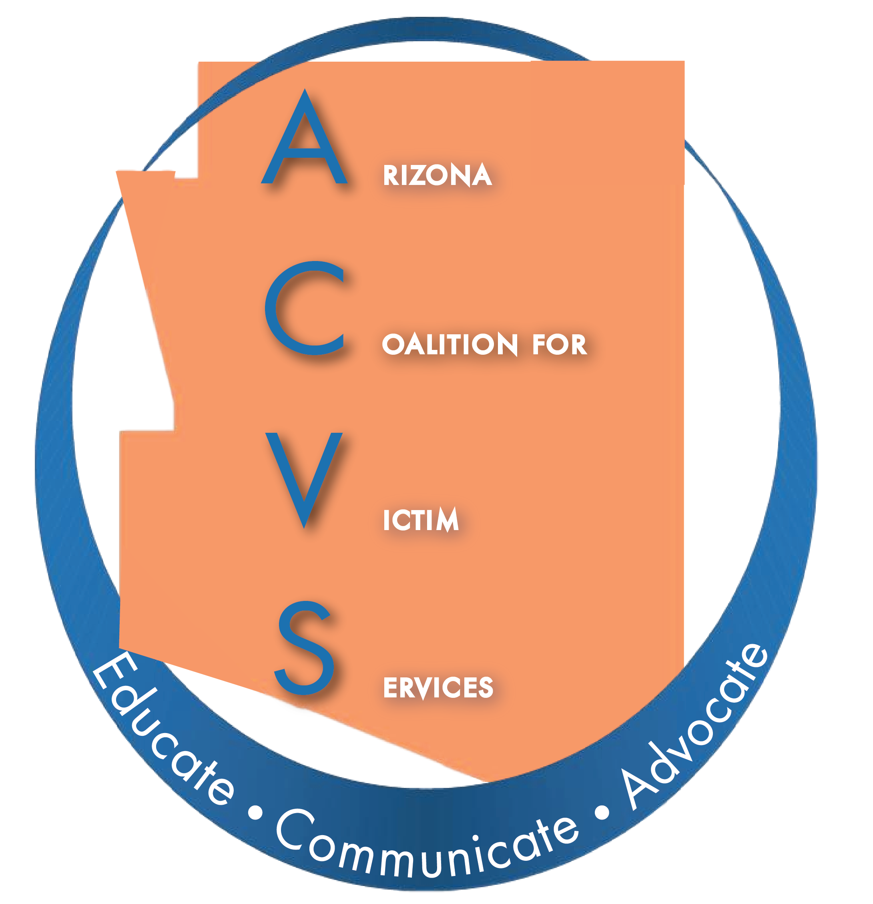

Arizona Coalition for Victim Services (ACVS)

Agenda – January 20, 2021 at 10:00am
VIRTUAL

- Call to Order – Amy Bocks, Chair
When it's time, join the Webex meeting here.
Meeting number (access code): 146 870 4249

Meeting password: | XCwB5Jsws38

Join meeting

Tap to join from a mobile device (attendees only)
+1-408-418-9388,,1468704249## United States Toll
Join by phone
+1-408-418-9388 United States Toll
Global call-in numbers
Join from a video system or application
Dial 1468704249@azag.webex.com
You can also dial 173.243.2.68 and enter your meeting number.

- Welcome and Introductions

- Welcome to Gretchen McClellan-Singh, Secretary

- Approval of November Meeting Minutes

- Mary Witkofski, City of Maricopa Family Advocacy Center

- Vote on 2021/2022 ACVS fee structure

- Legislative Priorities
  - Kennesha Jackson, Arizona Attorney General’s Office
  - Tanner Swanson, Arizona Coalition to End Sexual and Domestic Violence.

- Updates from ACESDV, Tanner Swanson

- State Agency Coordinating Team (SACT) – Funders’ Report
  - VRP, Kennesha Jackson, Arizona Attorney General’s Office
  - ACJC, Heather Bohnet, Arizona Criminal Justice Commission
  - VOCA, Kate Lyon, Arizona Department of Public Safety
  - DES, Laura Guild
  - DHS

- Arizona Victim Assistance Academy (AVAA), Connie Chapman

- Committee Reports
  - Executive Board Report, Marcy Morales
  - Treasurer’s Report, Isela Devora
  - Membership Committee, Marcy Morales
  - Relocation Committee, Tracy Wilkinson
  - Website Committee, Marcy Morales

- New Business/Open Forum

- Next Meeting – March 17, 2021, 10:00am, Virtual meeting - expected

- Adjournment

