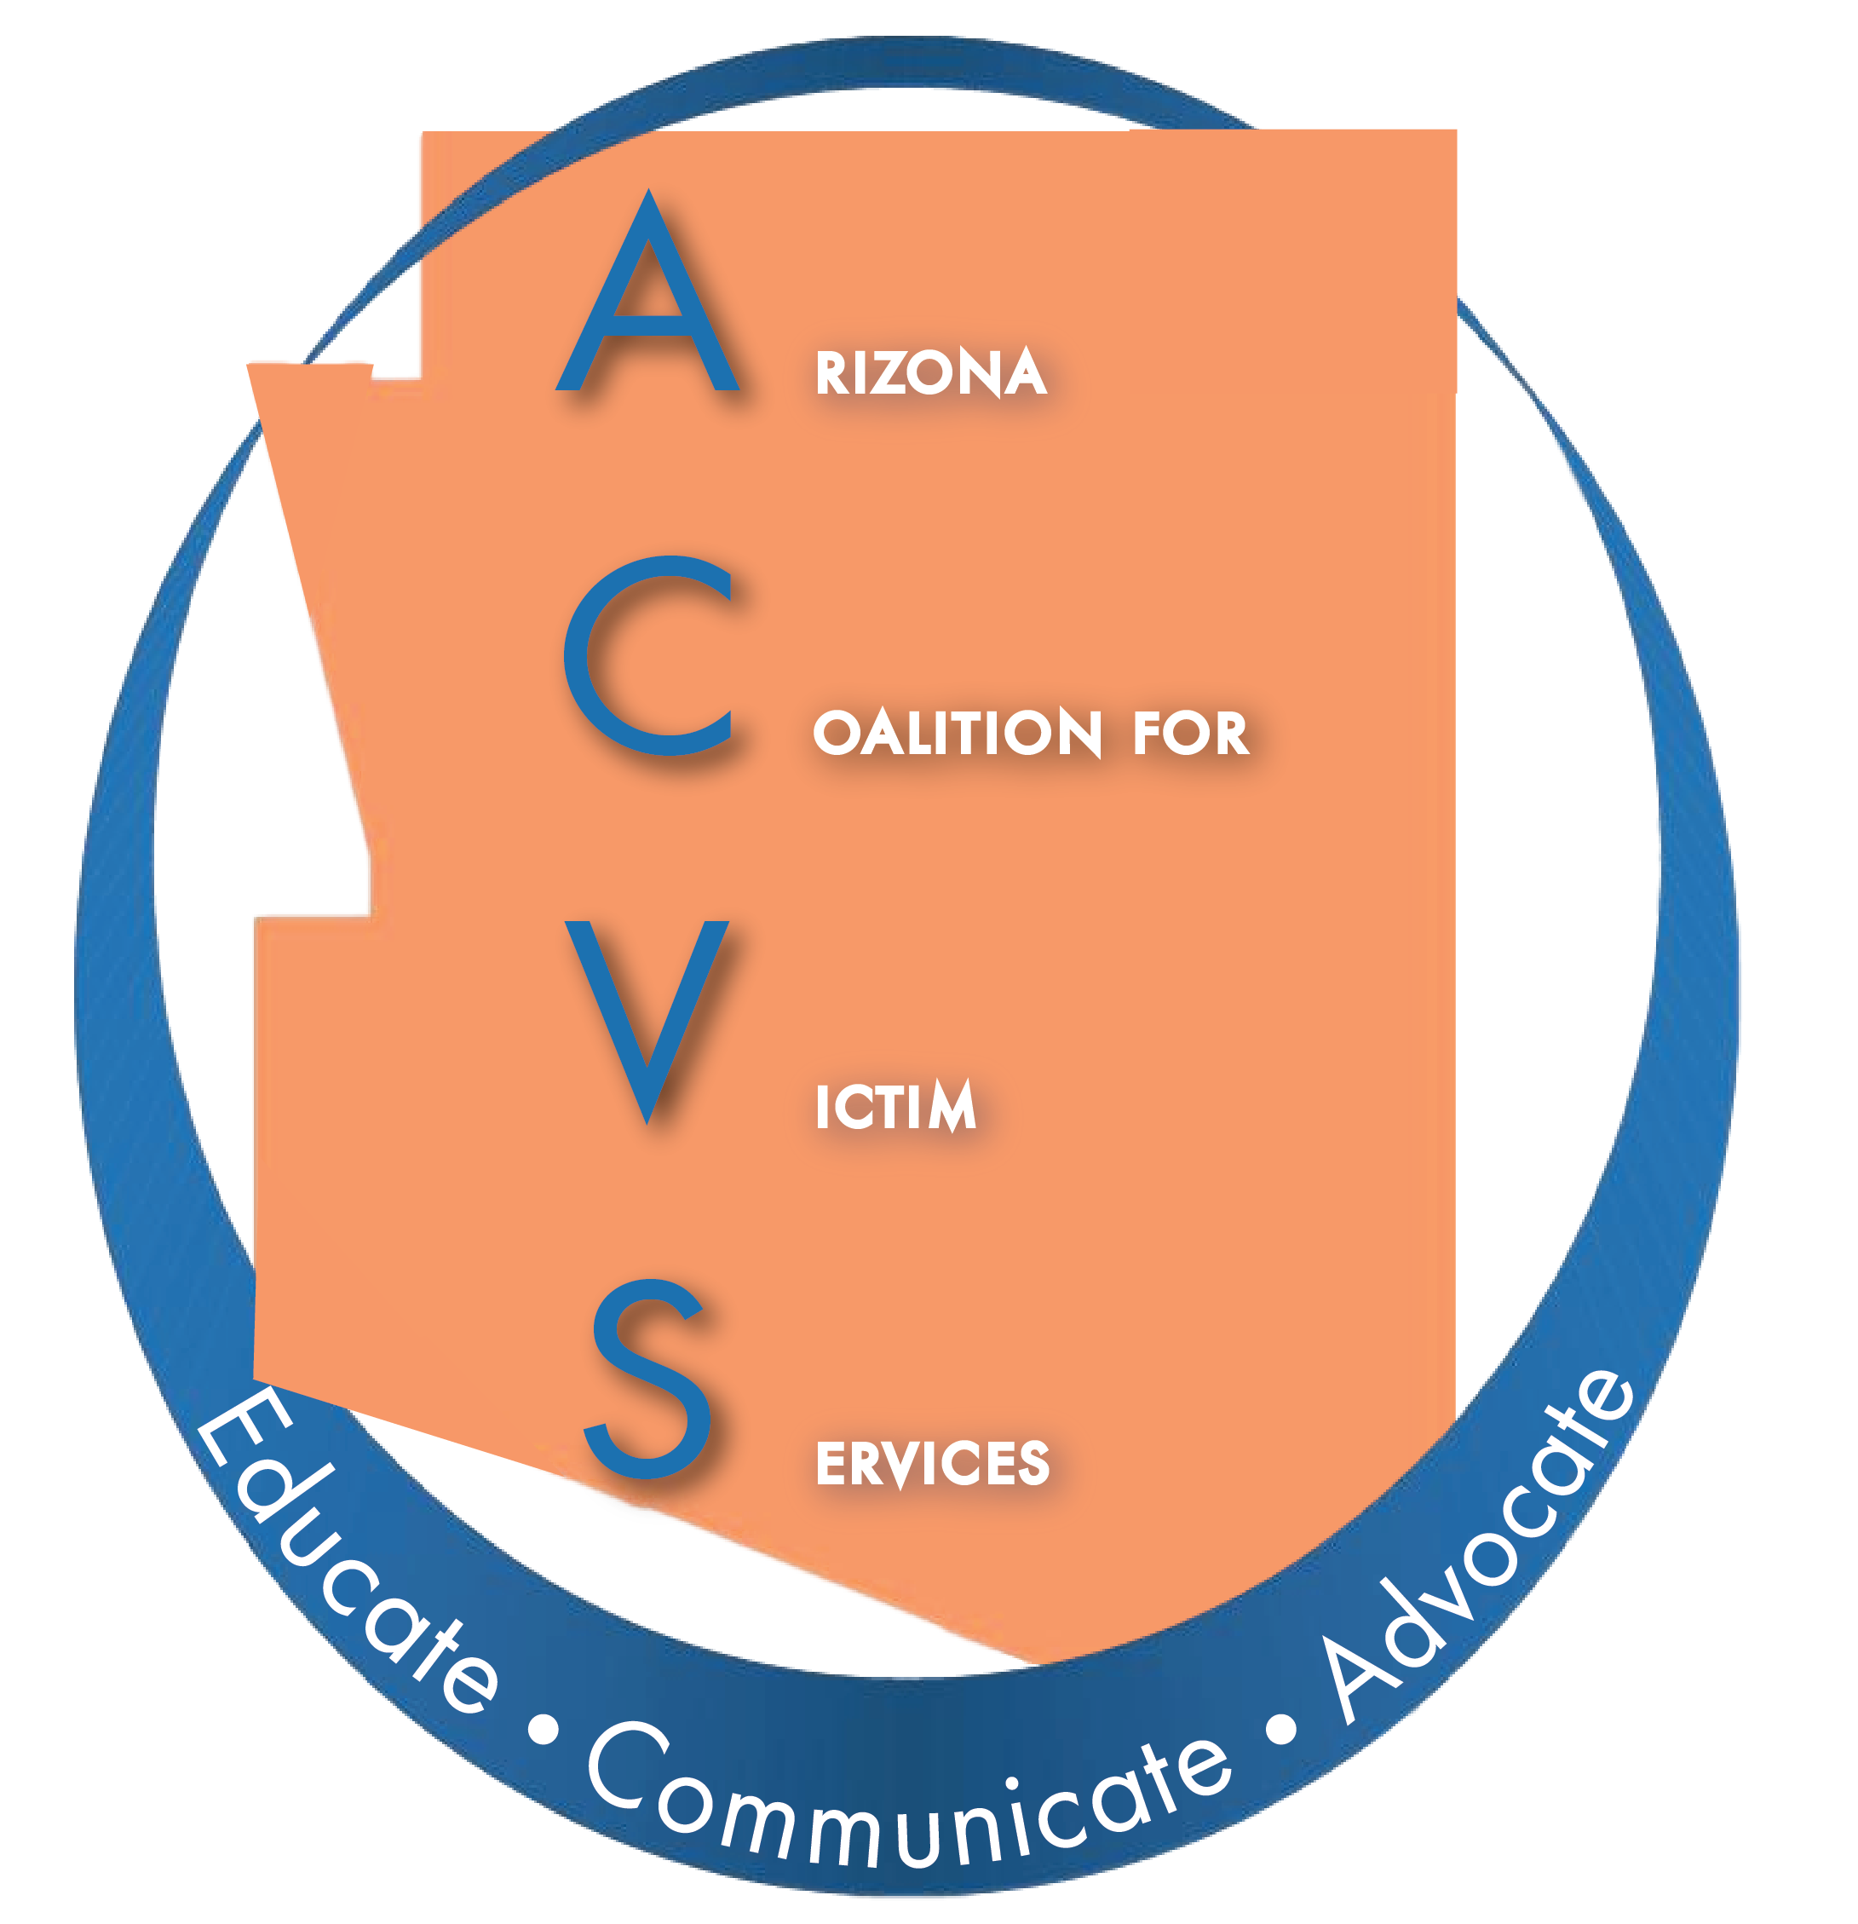

Arizona Coalition for Victim Services (ACVS)

Agenda – January 15, 2020 at 10:00am
Phoenix Family Advocacy Center, 2120 N. Central Avenue,
2nd Floor Community Conference Room, Phoenix, AZ

- Call to Order – Amy Bocks, Chair

- Welcome and Introductions

- Approval of November Meeting Minutes

- AZPOINT – Heather Bohnet, AZ Criminal Justice Commission

- 2020/2021 membership year vote
  - Voting right and benefits
  - Fee structure

- Legislative Priorities
  - Kennesha Jackson, Arizona Attorney General’s Office
  - Samantha Hinchey, Arizona Coalition to End Sexual and Domestic Violence.

- Updates from ACESDV, Samantha Hinchey

- State Agency Coordinating Team (SACT) – Funders’ Report
  - VRP, Kennesha Jackson, Arizona Attorney General’s Office
  - ACJC, Heather Bohnet, Arizona Criminal Justice Commission
  - VOCA, Kate Lyon, Arizona Department of Public Safety
  - DES
  - DHS

- Arizona Victim Assistance Academy (AVAA), Connie Chapman

- Committee Reports
  - Executive Board Report, Amy Bocks
  - Treasurer’s Report, Isela Devora/Amy Bocks
  - Membership Committee, Marcy Morales
  - Relocation Committee, Tracy Wilkinson
  - Website Committee, Marcy Morales

- New Business/Open Forum

- Next Meeting – March 18, 2020, 10:00am, Phoenix Family Advocacy Center, 2120 N. Central Avenue, 2nd Floor Community Conference Room, Phoenix, AZ.

- Adjournment

