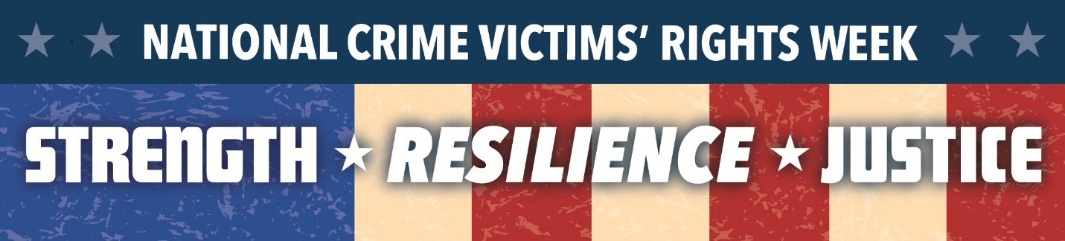
Navajo County Attorney’s Victim Services Division
2017 Victims Rights Symposium
Video and Poster Contest Release Form
“Suicide Prevention, Self-Harm and Escalating Behavior That Leads to it”

(For office use only) Poster/Video #____________
Student represents that the entry is an original work of authorship. Student hereby assigns the copyright and title of the entry to Navajo County Victim Services. Navajo County Victim Services shall have the right to use the entry for commercial purposes. This entry becomes the property of the Navajo County Victim Services and will not be returned.
Your entry must include both signatures below. Every student/person that participates in the video must sign this form and return it with the entry form. Teacher or counselor signatures will not be accepted.

Student Signature
Parent/Legal Guardian Signature

